Physical Development:

- Get undressed and dressed independently
- Show increasing control over an object in pushing, patting, throwing, catching, kicking …
- Hold a pencil/pen correctly
- Identify healthy/unhealthy foods

Communication & Language:

- Listen in a range of situations
- Join in with stories, rhymes
- Use talk to organise, sequence and clarify thinking, ideas, feelings and events
- Follow a story without pictures or props
Hedgehog Class

Autumn Term 1 2018
Amazing Me!

Personal, Social & Emotional Development:

- Class Rules and School Rules
- PATHS – exploring feelings
- Ask questions (who, why, what, where, when, does it, can you …
- Begin to negotiate and solve problems

Home Learning:

- Show and Tell preparation
- Reading
- Phonics, letter formation, number formation, reading bingo games
- Hedgy Hedgehog’s Adventures
PARENTS: Maths activities Tuesday afternoons
Christmas Crafts (date to be
confirmed)

Mathematics:

- Recite numbers to 20 and beyond
- Compare 2 groups of objects (more/less/same)
- Recognise numerals 0-5 then to 10
- Estimate how many objects they see then check by counting
- Order 2 or 3 items by length, height, weight or capacity
Literacy:

- Beginning to write own name
- Give meaning to marks they make as they draw, write and paint
- Continue a rhyming string
- Talk about stories they hear
- Hear and say initial sounds in words
- Segment the sounds in simple words and blend them and know which letters represent some of them
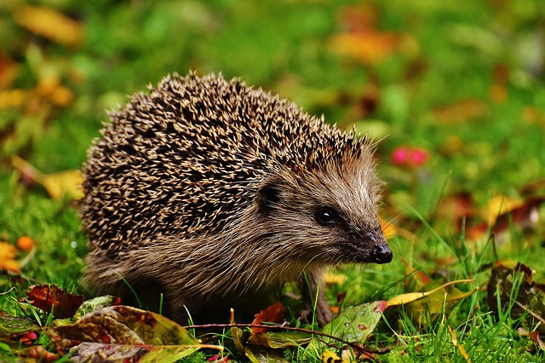
Hedgehog Class - Autumn 2 2018
Value for Life: Respect/Reverence
Visits: Norwich Cathedral

Expressive Arts:

- Sing songs, make music and dance
- Explore colour mixing
- Construct with a purpose in mind
- Engage in imaginative play
- Use a range of art and craft materials
- Use different methods to join materials
Understanding the World:

- Remember and talk about significant events in their own lives
- Talk about things they observe around them and about how they might change
- Think about similarities and differences between them and others
- Operate equipment ie ipads, camera, IWB, CD player, remote control toys

