Notes about characters
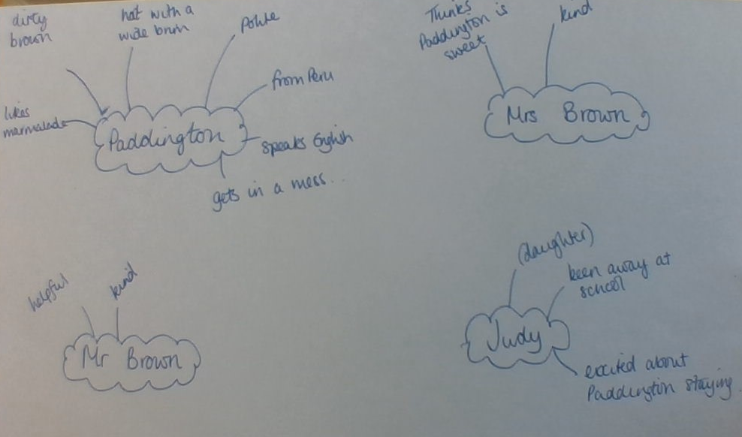
Some ideas, but not complete!

