Art/ DT

YR and Y1- Make a mask of a bear-
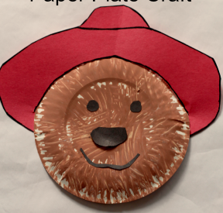
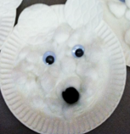
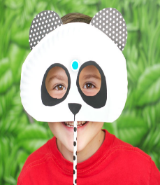

You could make a mask like one of the ideas above or you could design and make your own.
Y1-6 *Create a 3D model of a Spectacled bear using playdough/clay/ salt dough
*Wanting a challenge? Try making a DIY geometric bear. If you don’t want to include sewing you could just do some drawing using a straight edge and a pen.
https://www.youtube.com/watch?v=9l61hKhjfqc

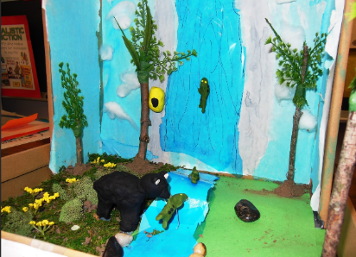
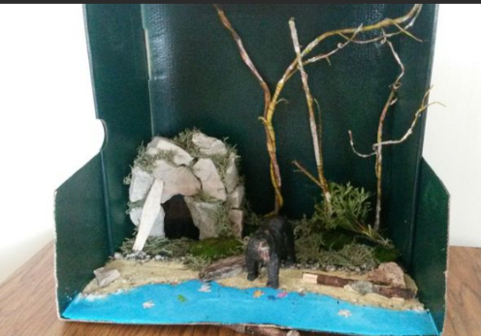
Any year group- Create a habitat in a shoebox or make a diorama (3D model) for an Andean bear.

