Common nouns and proper nouns
Learning Intention:  To identify common  nouns (and proper nouns) | Key Vocabulary: Common noun Proper noun Capital Letter | What you will need: Pencil  Highlighters or pens (don’t worry if you don’t have any)  Paper / Exercise book
Starter
Look at the picture

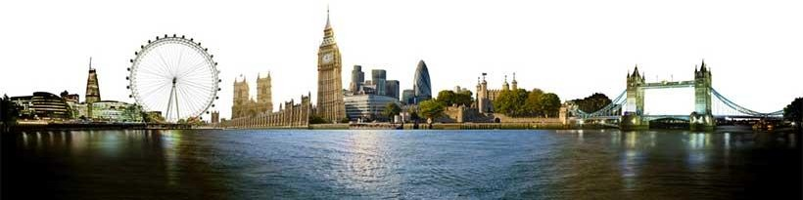
Talk about the picture. What can you see? Do you recognise this place? Do you know where it is? Have you been there before? What did you do when you were there?
Main Teaching
What is a noun?
A noun is a word that is a person, place, or thing e.g. river, plate, table.
All nouns can be divided into two categories: common or proper

What is a common noun?
A common noun is a name for a group of people, places or things e.g. teacher, country, car

What is a proper noun?
A proper noun is the name of a particular person, place, organization, or thing. Proper nouns begin with a capital letter. Examples are ' Margaret', ' London', and 'Sainsburys’.

How many nouns can you find?
You need a pencil and paper. Looking at the picture of the London skyline time 1 minute, see how many nouns and proper nouns you can see and then write down.

Tasks
You can complete either challenge 1, 2 or 3 (Challenge X is an extension challenge that you can choose if you would like to complete also). There is a simpler activity on a different document called ‘find the nouns’ which your child can do if they struggle with any of the challenges on here.
Challenge 1
Identifying common nouns and proper nouns

You can write two lists using the headings ‘common nouns’ and ‘proper nouns’.
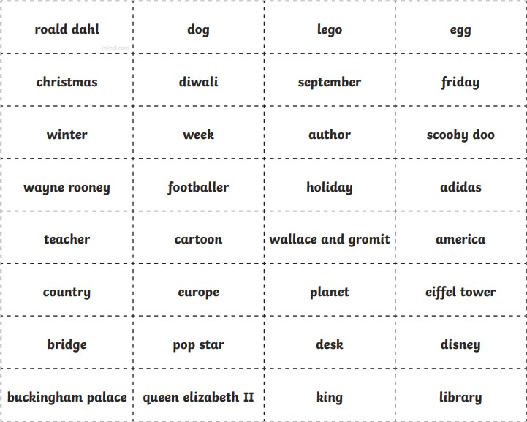

Challenge 2
Identifying common and proper nouns
Read the passage below and then using different coloured pens, highlight the different nouns. Don’t worry if you don’t have the same colours as below; use what you have or just use your pencil and make three lists using the headings ‘person’, ‘place’ and ‘thing’.

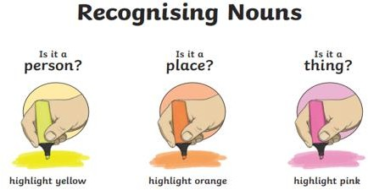

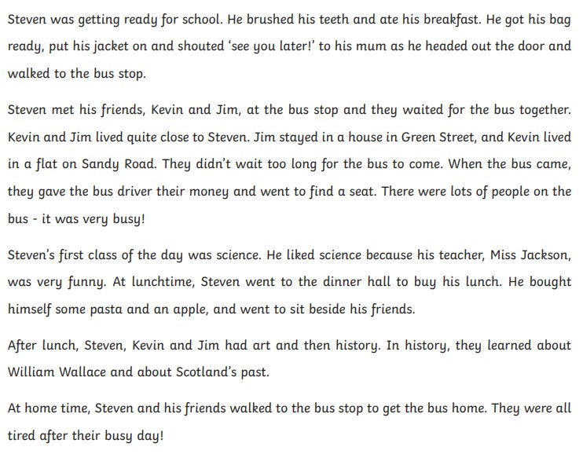
Challenge 3
Identifying common nouns and proper nouns
Read these sentences. Highlight the common nouns and proper nouns (or write them on paper). Have I used capital letters correctly? Cn you correct them for me?
- In London there is a massive Bridge called Tower bridge, it goes over a River called the thames.
- When you stand at the bottom of the shard you have to look way up into the Sky to see the top.
- I went on The London Eye and it really is just like a big Wheel.
- There are many buildings along the river Thames but my favourite is the stunning houses of Parliament.

Select 3 nouns and 3 proper nouns from Challenge 1, and write a sentence with them in.
Challenge X
Can you think of a proper noun and a common noun for every letter of the alphabet?

Learning Review
Review the nouns and proper nouns from the London skyline activity

