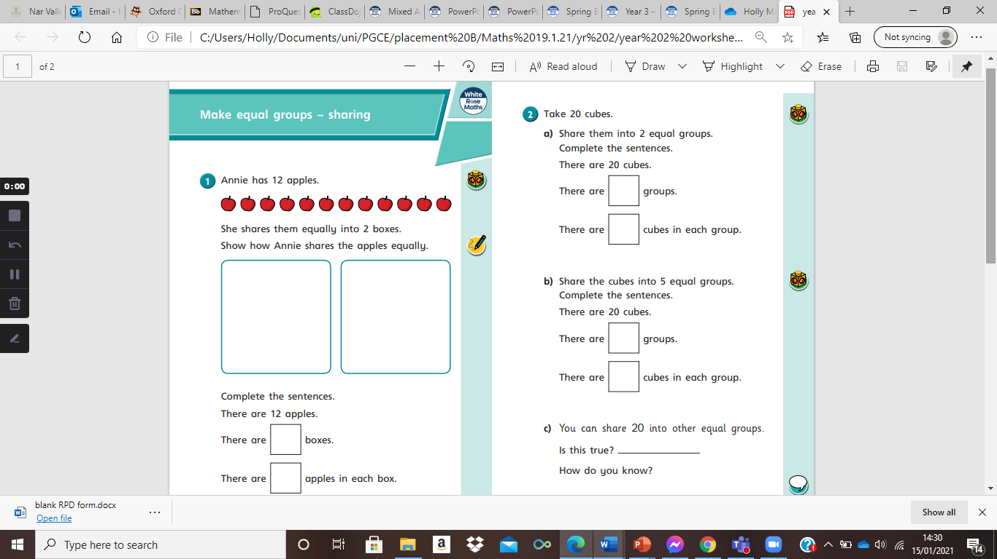
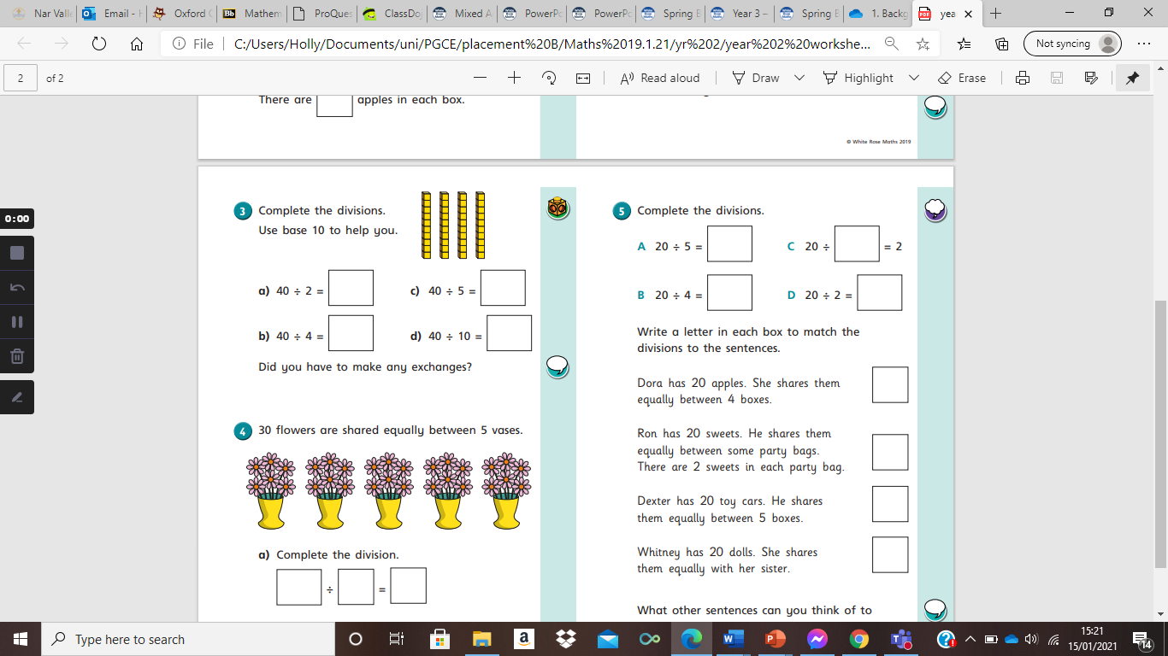
You have 16 bananas. Use the base 10 or counters
- Share them into 2 groups to help you.
Complete the sentences
20 $÷$ 5 =

20 $÷$4 =

20 $÷$ 2 =

20 $÷$ 10 =
There are 16 bananas
There are groups.
There are bananas in each group.

- Share them into 4 groups
Complete the sentences
There are 16 bananas.
There are groups
There are bananas in each group.
How else could you share 16 bananas? Can you create your own sharing question?

