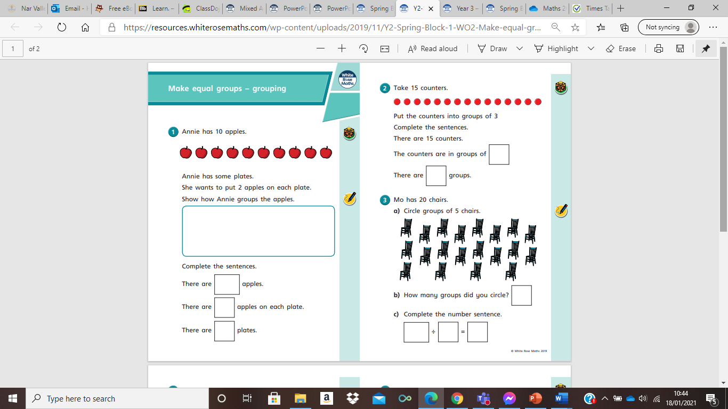

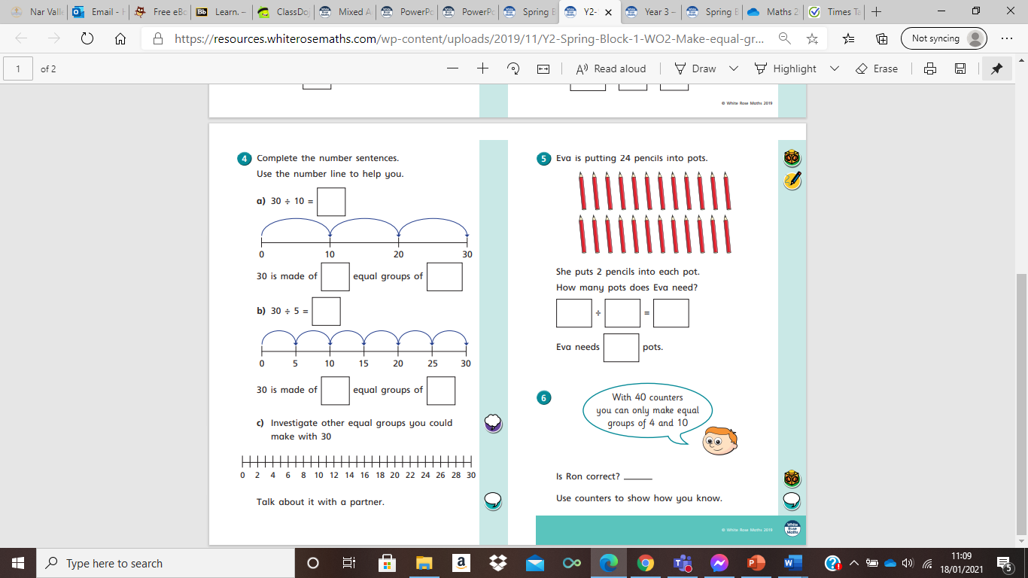
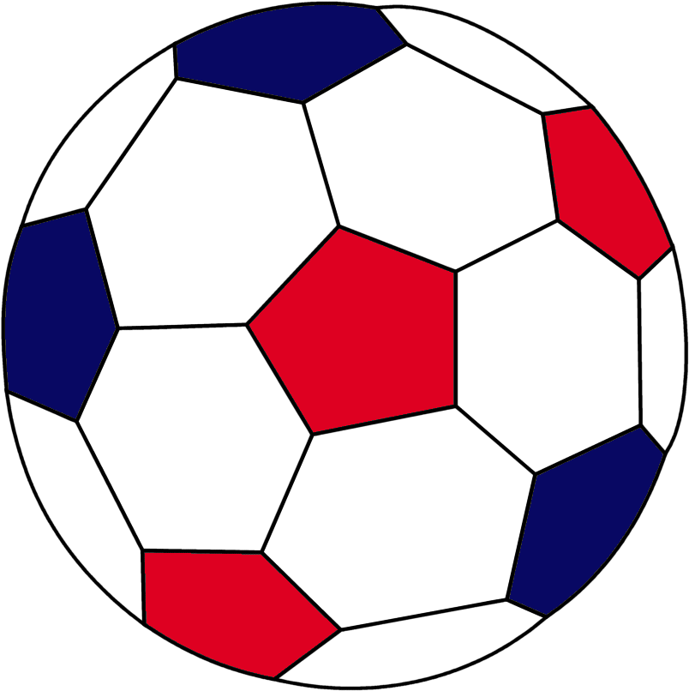
George has 18 balls.
Fearne has 21 sweets.
Fearne has some party bags.
She wants 7 in each party bag.
Show how would Fearne group her sweets?

Complete the sentences.
There are sweets.
There are sweets in each bag.
There are bags.
This Photo by Unknown Author is licensed under CC BY

Put the balls in to groups of 2
Complete the sentences
There are 18 balls.
The balls are in groups of .
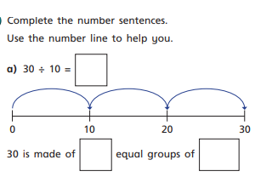
There are groups.

