Art Lesson 2
Last week we found out and wrote some facts about the artist Andy Warhol. This week we are going to learn more about his work by watching a video and then we are going to have some fun recreating and designing our own pop art!

Firstly, enjoy watching this short program about Warhol’s fascination with celebrity and the techniques he used to create his works - https://www.bbc.co.uk/teach/class-clips-video/art-and-design-ks2-andy-warhols-marilyn-diptych/z42r2sg

Let’s get creative!
Today’s task is to create your own pop art. You have a choice of three activities:
- Use the templates of doughnuts or cupcakes in the resources to create your own pop art.
- Design your own template of anything you like! Cut it out then trace it into the 4 quarters of your paper.
- Draw your own self-portrait, trace or copy into the 4 quarters of your paper.
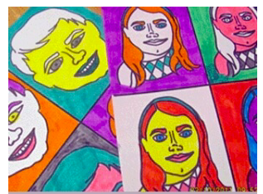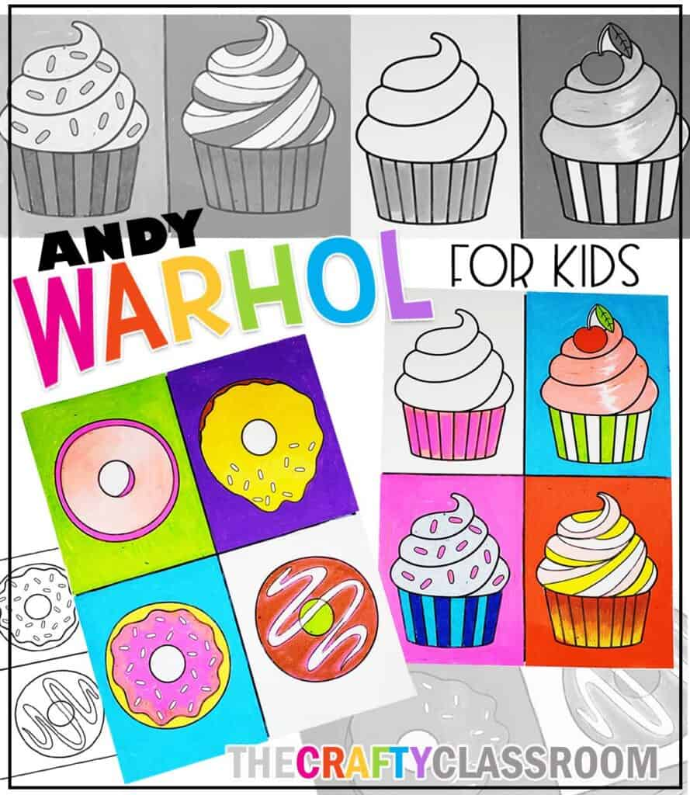

If you have some colours at home you can use the ideas below to bring your design to life. You can use felt tip pens, highlighters, paints, pastels, crayons etc. If you don’t have any colours don’t worry just pop a message to your teacher on Class Dojo.

HIGHLIHGTING
As you fill in the different shapes of your design, look for opportunities to highlight. You can do this by leaving white space around the edges of your shape, then returning to fill them in with a bright colour. In the example below the doughnut is coloured brown and highlighted with a vibrant pink around the edges of the icing and the edges of the doughnut itself.

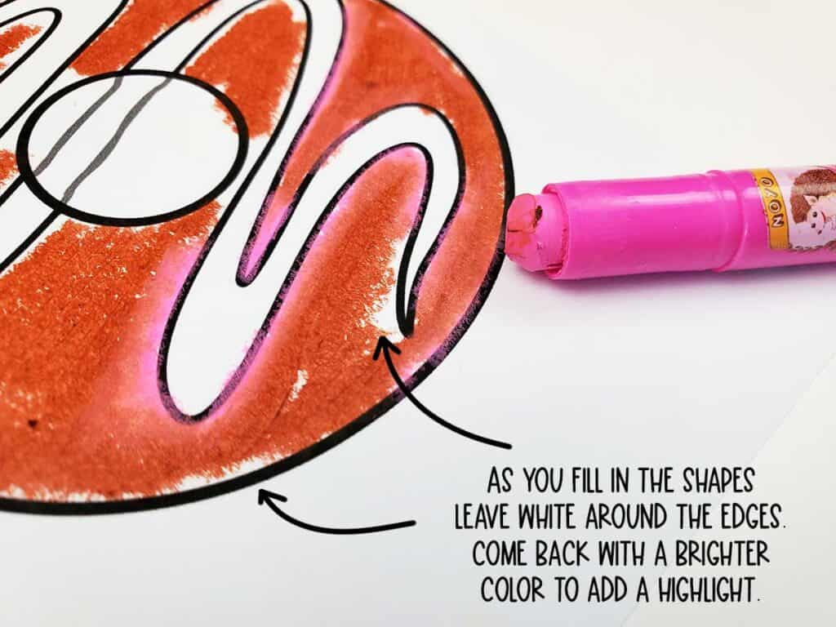

COMPLIMENTARY COLORS WITH POP ART
When choosing colouring for your shapes and your background, look for complimentary colours to help them POP! Complimentary colours are visually interesting and they complement each other.

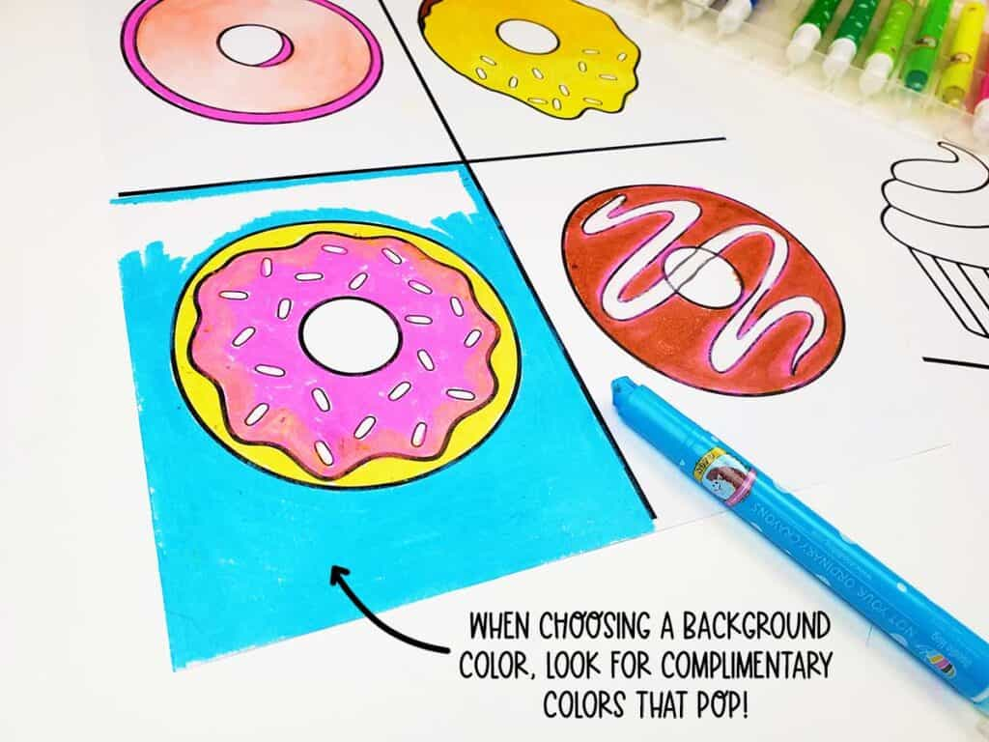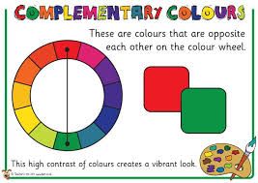

Don’t forget to post your wonderful work on class dojo!!

